SMART PACKING PHASE-2
In this phase 2 we are going to discuss about the innovation of smart parking problem solution. We are discussing above the various method of solutions in this document.
Overcoming incorrect parking using IoT (Internet of Things) involves deploying technology and strategies to prevent and address unauthorized or incorrect parking. Here are some steps to tackle this issue:
1. IoT Parking Sensors:
Install IoT sensors in parking spaces to monitor occupancy in real-time.
These sensors can detect when a parking space is incorrectly occupied.
2.Automated Enforcement:
Implement automated enforcement mechanisms that issue tickets or alerts
when incorrect parking is detected through IoT sensors and cameras.
3. Real-time Monitoring:
Use IoT-based solutions to provide real-time parking status to users. This can
help drivers find available parking spaces more easily.
4. Mobile Apps:
Develop mobile apps that allow users to report incorrect parking and request
assistance. Users can take pictures and provide details through the app.
5. Parking Guidance Systems:
Install digital signs and LED displays that guide drivers to available parking
spots and inform them about the correct usage of spaces.
6.Variable Pricing Models:
Use IoT data to implement variable pricing models that charge higher fees for
incorrect or unauthorized parking. This acts as a deterrent.
7. IoT Cameras:
Use IoT-enabled cameras to capture images of incorrect parking. These
images can be used as evidence for enforcement.

8. Provide real-time parking availability by employing sensors or camera detection systems.

Cities can provide real-time parking spot availability to drivers using smart parking technologies such as sensors or video detection systems. The sensors are put in the pavement of each parking space to detect the presence of cars, while the video detection system employs a camera to monitor and report on the availability of the whole parking lot (up to 200 parking spots per camera). To provide information about parking spot availability, a smartphone app, online portal, or on-site terminal are most used, Drivers can then take advantage of this information to plan their routes more precisely when driving into downtown areas with limited parking.

9.Clearly communicate up-to-date availability information by installing parking displays throughout the lot.

As an add-on to smart detection systems, installing parking displays is an excellent way to provide drivers with clear information about parking availability at strategic points throughout the lot, such as the beginning of an aisle, parking rows, and even entrances and exits. This type of solution creates a more seamless experience for drivers by providing them with up-to-date information on available spaces. This way they can quickly determine if they should continue driving through or if they should turn and find another place to park.
10. Parking Monitoring:
Another task that an IoT Smart parking management system solves is monitoring the
movement of people and cars in a parking lot. Integrating video surveillance into the
system can improve parking administration and troubleshoot potential problems,
such as traffic accidents or theft, by controlling which cars enter the area.
11. Parking Reservation:
An IoT-based smart parking system also solves the problem of overcrowded parking
lots. It allows drivers to reserve parking spaces in advance through a mobile
application or web interface.
It’s also possible to use individual solutions like parking locks for reservations. These
are devices installed directly on parking slots. When a parking space owner leaf
the territory, a parking lock will block entry for other cars.
12. Proper management of disabled areas
To overcome this challenge, consider the network requirements and constraints of your IoT project. You also need to adopt the appropriate protocols and standards for IoT connectivity and interoperability. For example, you can use wireless technologies, such as Wi-Fi, Bluetooth, or cellular, to connect your devices.

13.Energy saving solution:
An IoT energy-saving system allows the automation of numerous processes. In
it can collect energy data from IoT devices for measurement and analytics.
As a result, employees can concentrate on developing successful energy management
strategies as they don't have to perform as many manual tasks.
The smart parking system to be developed has four actors whose needs the system must satisfy. The primary actors of the system include car drivers, system administrators, parking enforcement officers, and the city planning authority. The below Figure shows the use diagram of the system highlighting the actors and their actions.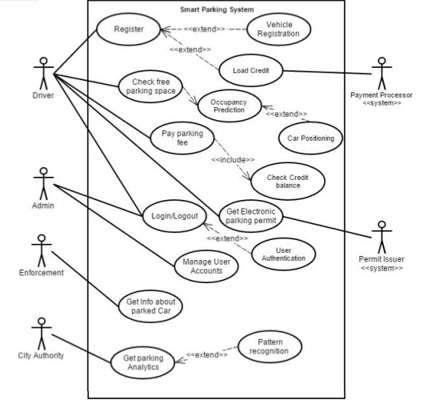

the secondary actors include the payment processing system and the parking permit issuing system. The Driver must Register to the created account. The Payment Processor the external system is used to process the payment. The driver checks for available empty parking spaces in the part of the city before driving there. The check free(empty) parking space depends on the Occupancy Prediction engine which includes the execution of Car positioning algorithms. When a driver finds a parking space, the driver wants to Pay parking fee which action requires the system to Check Credit balance to cover the parking fee due. The driver furthermore wants to Get Electronic parking permit, this action invokes the Permit Issuer an external system that manages the issuance of parking permit. The admin, just like the driver, both have to Login/Logout and the system must verify that they are who they claim to be using User Authentication engine. The system admin also wants to Manage User Accounts in case of a problem or during routine maintenance of the system. The Enforcement officer wants to Get Info about parked Cars which tells if a car has a parking permit or if it has the parking event running at the end of which the parking fee would be paid. The City Authority want to Get Parking Analytics to predict the parking behaviours of the drivers in the city to aid their city planning. This action involving the Pattern recognition engine that looks for patterns and correlations between different data set of parking events and occupancy.
There are many methods are available .We can make use of the best method among them.

